**Sir William Peak, O’Leary & The Dart**

**2 Nov 2020**

**Definitely Just Trampers: Jason Rose, Christine Borland, Emma Strack, Ivan Andrews**

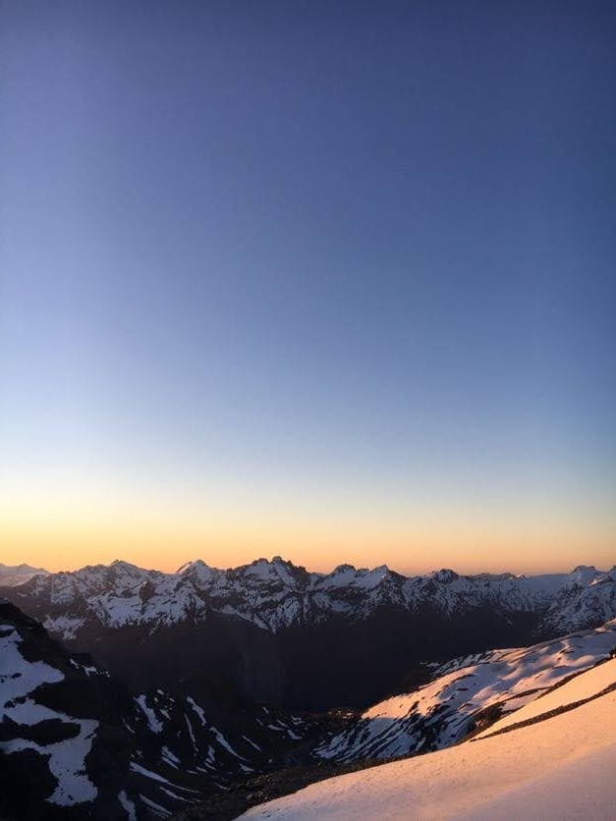

"If you fail to plan, you plan to fail." - someone who's never gone tramping, probably.

Like all good times, this one started with leaving Auckland. After my arrival in Christchurch airport I was picked up by my friends Ivan, Emma and Christine. We had originally planned to walk into Plateau Hut in Aoraki. We'd stay there for a week using it as a base for climbing, but a surprise NWer vetoed the idea categorically. After much consulting with the weather gods, and numerous entrail divination of squashed possums, we decided that fleeing further south would be our best option for something more resembling a tramp than an involuntary canyoning trip.

After a mind-numbing 7 hour drive to Glenorchy later, we passed out in a campsite. We resolved that Ivan and I would climb up the stunning Pluto peak, having climbed up Mt. Earnslaw together a couple of years ago, with Christine and Emma keen to climb the latter. The plan was to walk up the Dart valley until Sandy Bluff, then proceed to bushbash uphill for 800m, negotiating our way to Pt. 1626, crossing into the Bedford valley and then up to Esquilant Biv at 2240m. Given our starting point near Paradise at 400m, the largely untried and arbitrarily obtuse nature of the route, this was an ambitious notion. This was to say nothing of carrying four days of food and climbing gear with us. 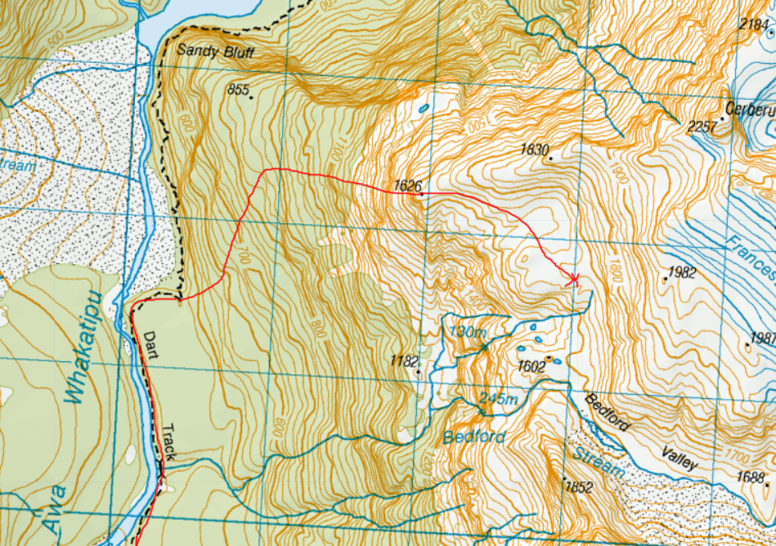

The day began with some amount of faff, a healthy quantity of skepticism re my 40L pack and extreme suspicion of my chip only diet. Further concerns were raised about my apparent total lack of water consumption, which I suspect is why some people believe that I am secretly a pile of potato chips in a trenchcoat.

Such concerns were hopefully put to rest following what ended up being a strange combination of 1200m of bushbashing, hounded by sandflies the whole way, cragging and desperately grasping at vertical speargrass and dracophyllum until we reached the most noble of peaks: Pt. 1626. It was starting to get dark by this point and our ability to find apparently every single bluff, crag and cliff in the South Island on the bash up hadn't helped. If y'all one of those rock climbing weidos, check it out! Fabulous cliffs, literally everywhere. You can't miss them if you tried. Trust me, we did.

We had hoped to get to Esquilant Biv that night, but the route from the Bedford up to Wright Col wasn't obvious, with what appeared to be thin snow over slab. It would have probably gone just fine with the evening freeze, but Ivan had unfortunately contracted some sort of plague and was rather keen to head off to bed, and there was little point pushing on. Both routes did not seem to be in anything approaching passable condition, so we decided to camp in the stunning Bedford valley. Our energy levels were also compromised from the exsanguination inflicted upon us by the swarthy hordes of sandflies, speargrass and dracophyllum. I got to put to the test my 550g synthetic DIY quilt as well, which performed excellently in our 1800m bivy spot.

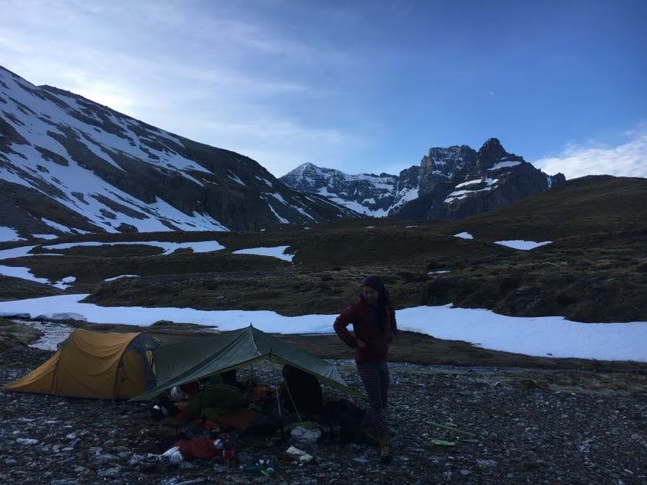

The next morning after even more faff, we headed off up slopes to Sir William Peak, taking a moment to chill at Shepherd's Pass. Ivan's plague had continued to get worse, so we had no choice left but to bust out the big guns: Ibuprofen and Paracetamol. It was with a heavy heart and a heavier hand that I dispensed those bitter pills, but the situation was clearly dire. Ivan was no longer in front charging up the slope. Something needed to be done. 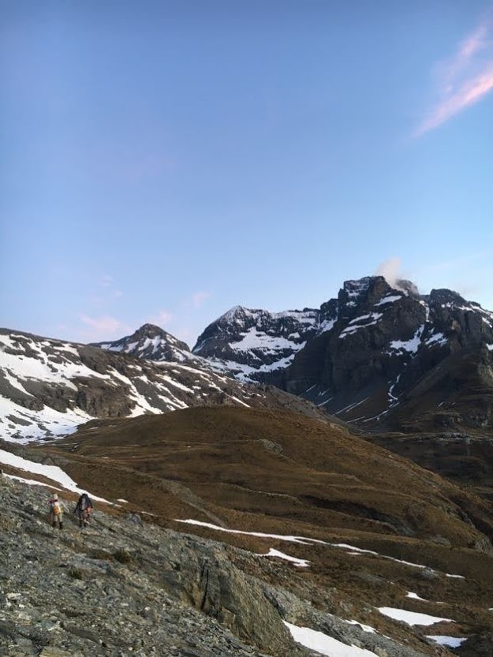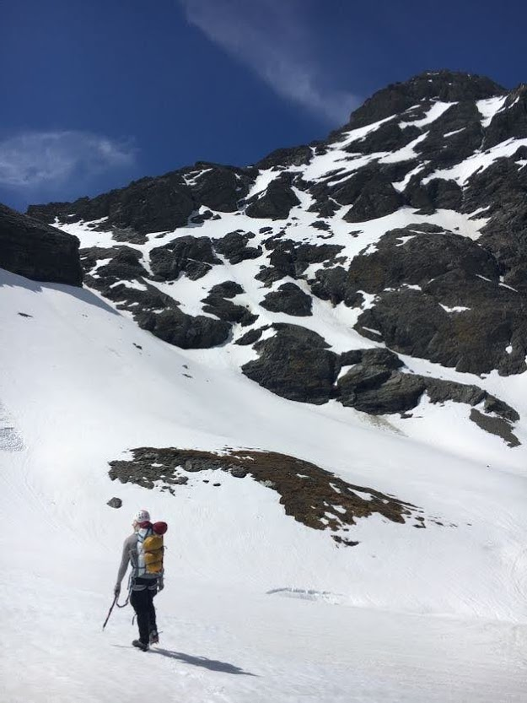

Fortunately this worked, possibly too well, and we found ourselves engaged in engaging some engaging grade 2 tramping. Chossy, blank and exposed slabs up to Luncheon Col provided no obvious route up, and Ivan couldn't seem to suss one. After some meandering, I managed to work out a route past the crux, bashing in my lucky piton at the top to throw my rope down for folks to use as a handline. We had a spot of lunch at Luncheon Col, and the summit of O'Leary Pk was enjoyed.

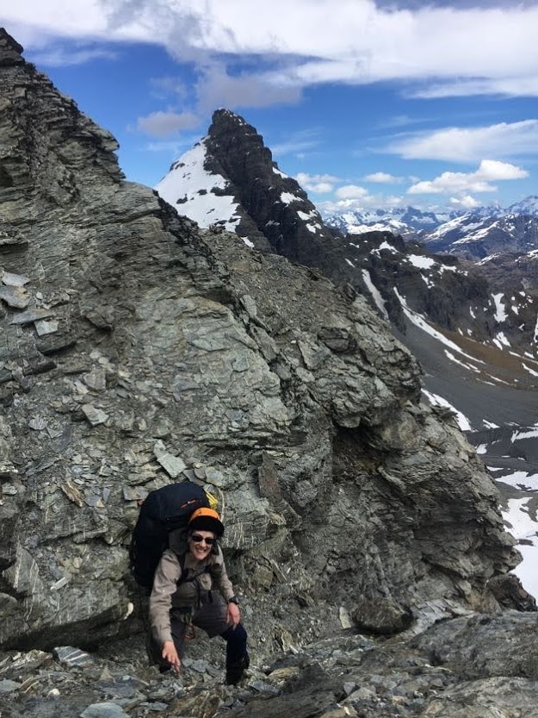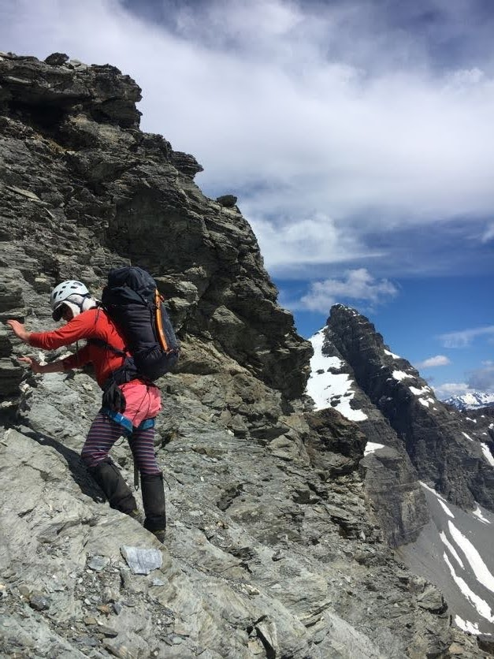

We resolved to sleep im Esquilant Biv that night, given how cute it is, and began our descent of the South East face of O'Leary. Unsurprisingly, we were bluffed out constantly. We eventually managed to find a steep snow-ice slope down to the Birley glacier, but most of us weren't comfortable soloing the down climb. Ivan and I dug a T(ramping)-slot, using his walking axe that he got for his 21st as an anchor. With everyone having rapped past the steep section, I gathered the walking axe and flaked the rope over my shoulders, and began the airy traverse above the Birley glacier and bluffs. It was my intention to downclimb a slightly less steep section, given the fact that one of my crampons were held onto my annoyingly bendy tramping boots with prussik cord. I ended up encountering a brief section of 50-60deg water ice on the traverse, which proved rather engaging. But the hardness eased and provided excellent shaft plunging conditions down to the Birley glacier, even if the steepness persisted, something that was well appreciated given the regrettable setup on my feet. Wouldn’t have volunteered to do it though if I wasn’t comfortable with it, there’s nothing wrong with leaving gear to rap off, folks.

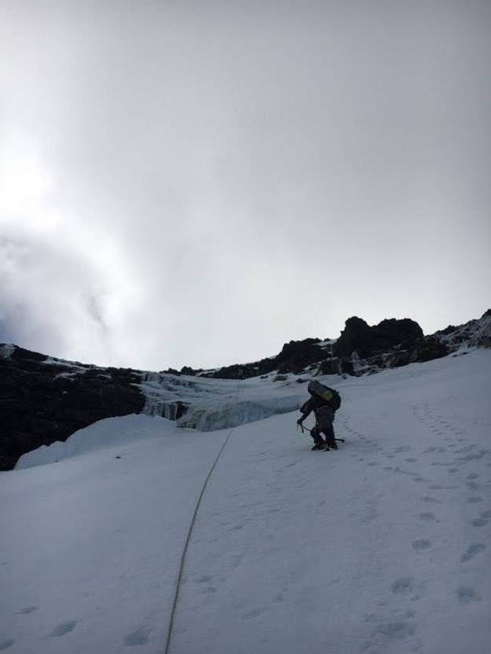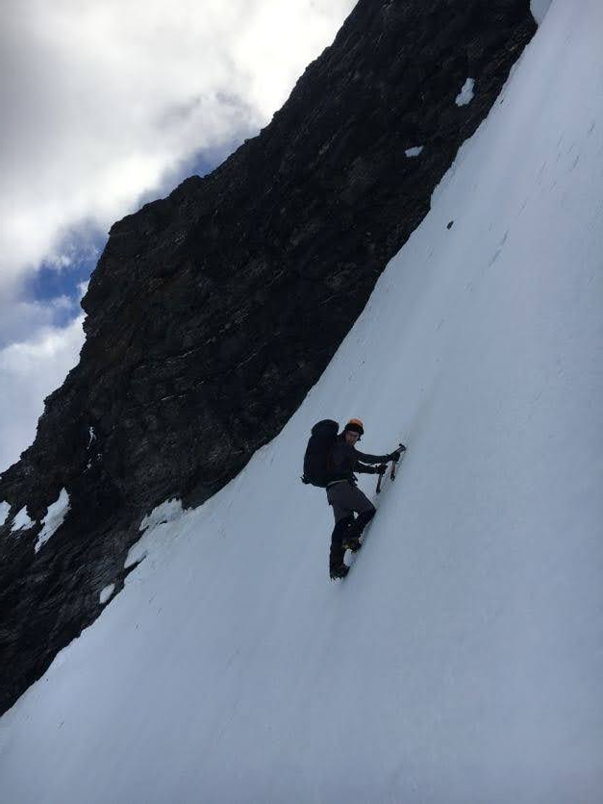

I suspect the others were a bit worried about me though, and Ivan perhaps a tad embarrassed that I'd done it all to rescue his walking axe, so I was pleasantly surprised to find that he'd climbed up partially to kick me a platform to grab the rope off me. Thanks Ivan! You didn't have to <3

With that whole affair having taken up much of what remained of the daylight, we plonked up over to Esquilant biv. Some lovely Glenorchy locals did an amazing job to accomodate all of us in the extremely small biv, and we all got a cozy night's sleep. Except Ivan. He slept in the tent outside and was very cold. Poor fella :(

The original plan was for myself to accompany Emma up Earnslaw early in the morning, then proceed to kea basin then up over Lennox pass, all the way along the ridge down to the Earnslaw burn track. An ambitious day, but pretty on-brand for us at this point. When Emma and I got up, the mountain was covered in clag. It was a no-go, and we slept in instead. After the requisite amount of faff in the morning, we charged down to Kea basin where we had a critical morale crisis - the NWer from Aoraki had found us! It was raining all along the high peaks and the clag was thick. There would be no high traverse today. With reluctance, we charged down the Rees valley, dreading the 40km roadbash ahead of us if we couldn't cross the Rees river. After a stupid amount of roadbashing and some failed crossing attempts, some encounters with barbed wire and twisted ankles, we surrendered and camped along the rees Valley road. Emma and Christine would attempt to hitch back to the Dart to grab our car and pick us up.

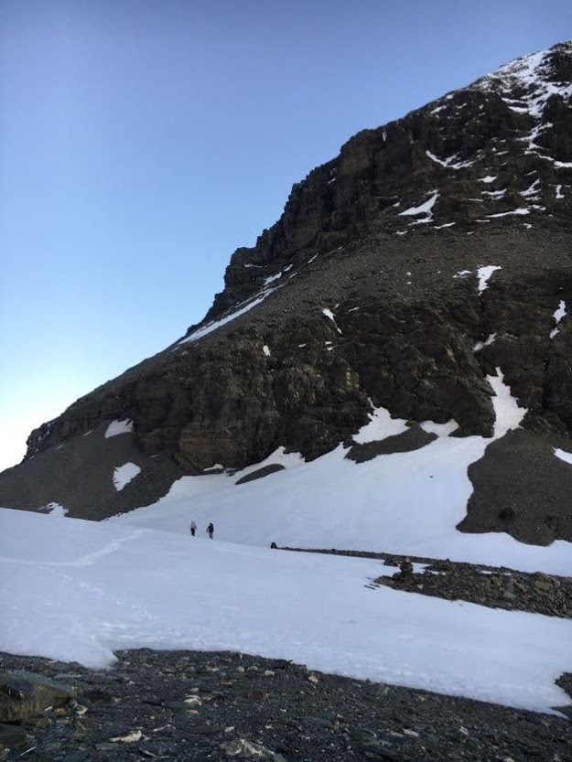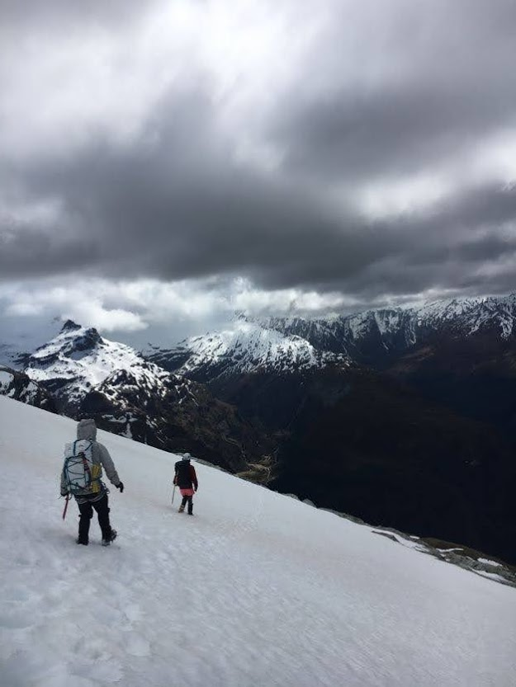

Fortunately for us, the Glenorchy locals were absolute sweeties. Emma and Christine had great luck getting a ride to the car while Ivan and I developed tolerance to sandfly bites. I might have gone slightly overboard with the tolerance bit, ended up getting hives and a wheeze with all of the bites - but Christine once more came to the rescue with antihistamines. Fabulous trip, 10/10 would trip again.